Task 1:

Output:
('EE06BD8A621CAC3B608ACFDF0585A76A', 357)
('11DC93DD66D8A9A3DD9223122CF99EFD', 353)
('6C1132EF70BC0A7DB02174592F9A64A1', 349)
('23DB792D3F7EBA03004E470B684F2738', 347)
('A10A65AFD9F401BF3BDB79C84D3549E7', 346)
('738A62EEE9EC371689751A864C5EF811', 345)
('7DA8DF1E4414F81EBD3A0140073B2630', 342)
('7D93E7FC4A7E4615A34B8286D92FF57F', 338)
('021F88711374FB07E02F03A06637C5C8', 338)
('0318F7BBB8FF48688698F04016E67F49', 337)

Spark History Screenshots:
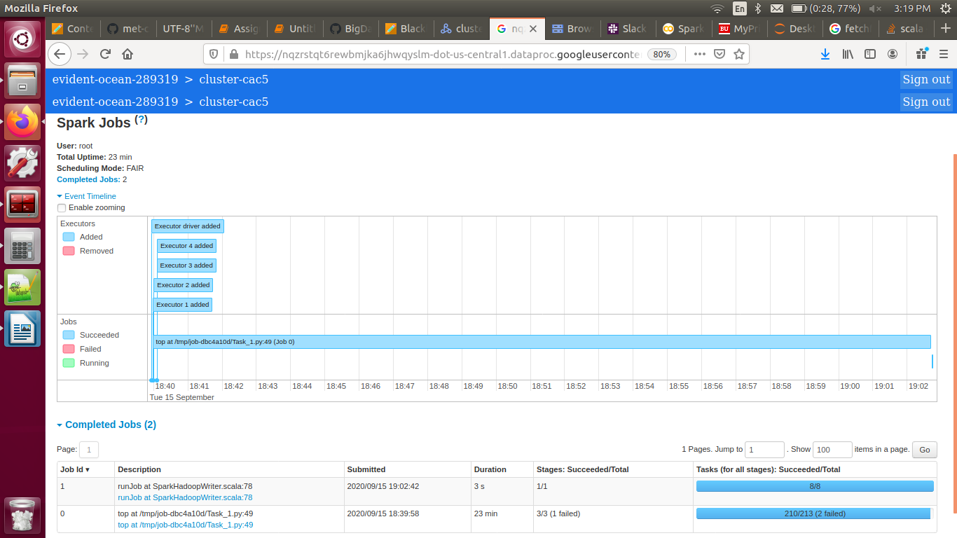
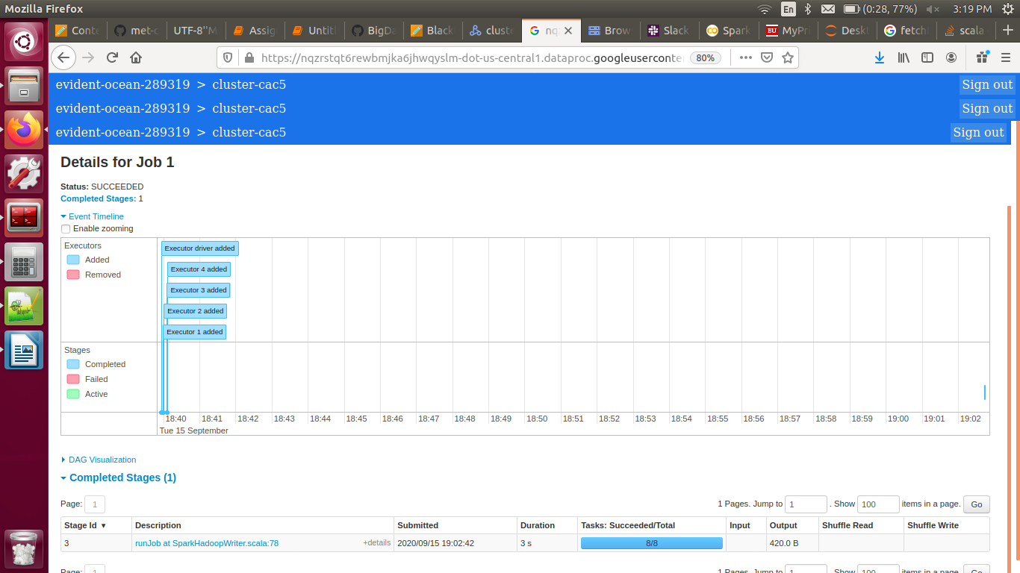

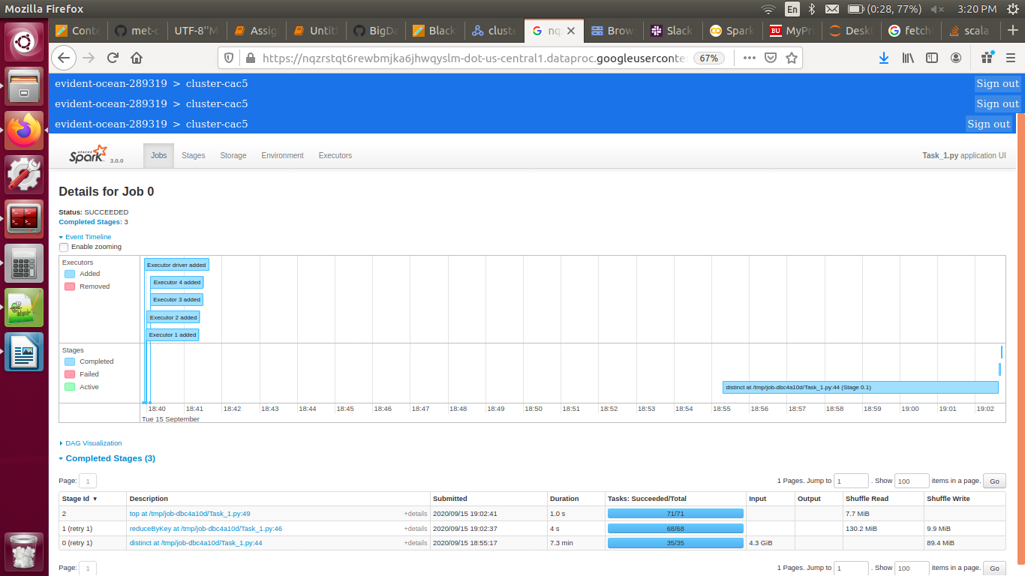

Task 2:

Output:
('FD0335369F7751C6C69BA6845A388C82', 72.16)
('A45A1D12EE0FB7F1F872AB91DA18F899', 72.09)
('20B5E1CF8694AF7A3C1BA4A87F073021', 69.92)
('324D6935EC71A4FDE749BF9924F3AE63', 60.0)
('6BD36B69E9ED9792AF6AD29CB7EE977C', 52.69)
('197636D970408B80F9A7736769BF548A', 52.5)
('5551DB0E22A5158C43B834D2360726D6', 52.5)
('26CE3538A4C4B3F201D8FF820577FA06', 51.16)
('944BDD9636749A0801C39B6E449DBEDC', 48.21)
('E17184BCB70DCF3942C54E0B537FFC6D', 47.0)

Spark History Screenshots:
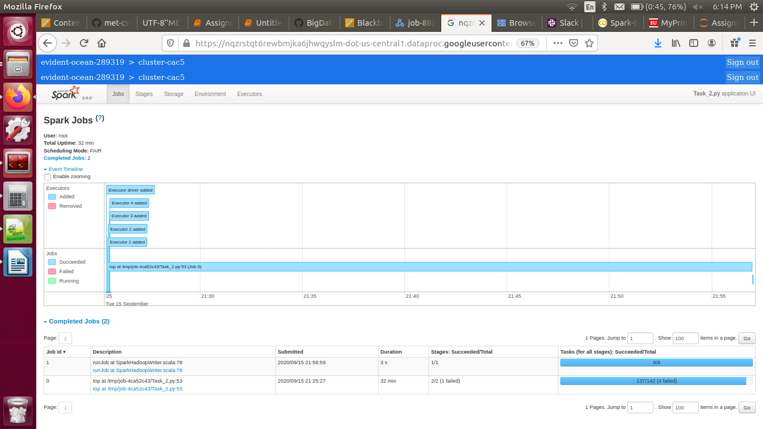
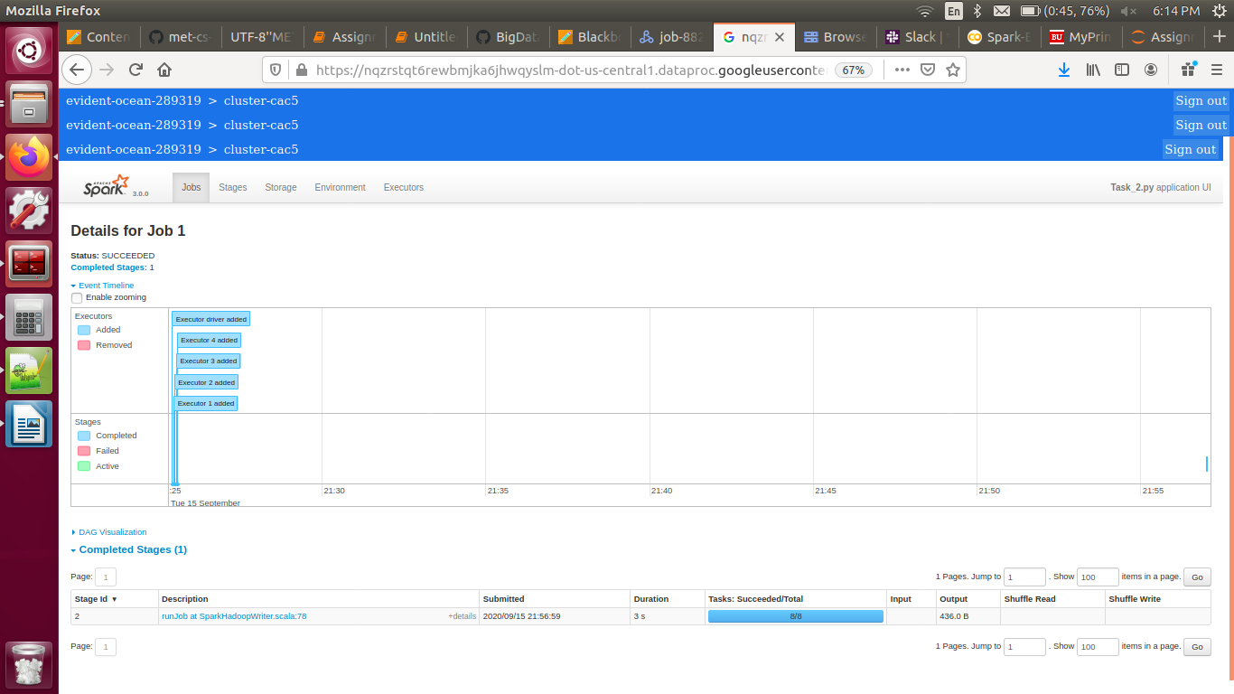
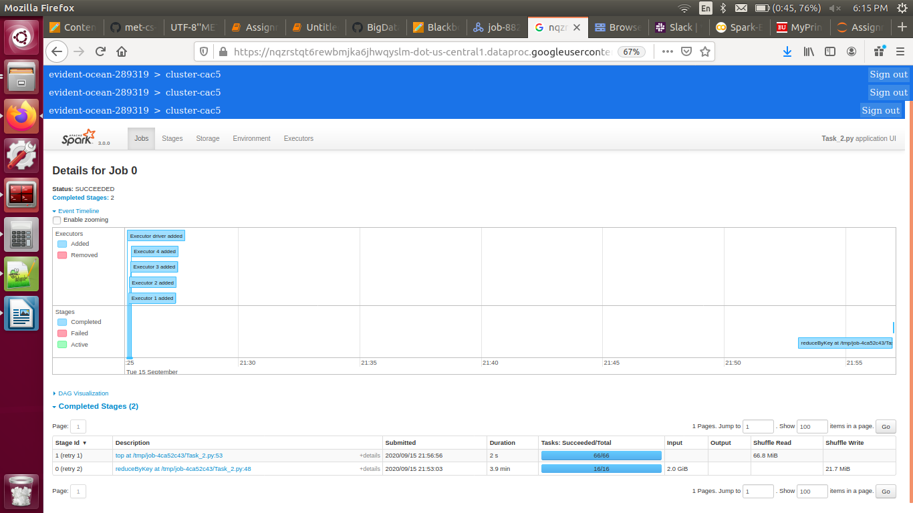

Task 3:

Output:
('15', 0.39)

Spark History Screenshots:
